Autonomous ML Engineer Crew
Project Ideation and Implementation Plan
Revised 19 October 2026

Overview
The Autonomous ML Engineer Crew automates the supported machine-learning workflow from a raw CSV dataset to a deployed prediction service. A user provides a dataset, target column, and prediction goal. The same five established agents validate and prepare the data, train candidates, evaluate the selected model, retry tuning when necessary, and deploy an accepted model behind a /predict API.
The revision does not change the objective, intended users, agent roster, agent responsibilities, supervised classification and regression scope, or evaluator-to-tuner retry loop. It defines the technical contracts and evidence needed to satisfy the course minimum requirements.

User Outcome
- A trained model that predicts new tabular records.
- A live authenticated /predict endpoint and a /health endpoint.
- A concise model report card describing the selected model, evaluation metric, threshold, and result.
- Usage and error monitoring linked to the execution trace.
- A reusable pipeline for another compatible CSV dataset.

Fixed Agent Architecture
Agent | Responsibility | Implementation framework
Data-Prep Agent | Clean and validate data, handle missing values, engineer features, flag quality issues | CrewAI
Model-Selection and Tuning Agent | Train candidate models and run bounded hyperparameter search | Google ADK
Evaluation Agent | Evaluate held-out data, apply a justified threshold, issue pass or retry feedback | CrewAI
Deployment and Observability Agent | Package, deploy, and monitor the accepted model API | CrewAI
Orchestrator | Manage order, shared state, validation, routing, and retry termination | CrewAI Flow

CrewAI and Google ADK are the only agentic frameworks. The mapping makes the existing ADK model-selection core the remote specialist while CrewAI continues to coordinate the surrounding workflow.

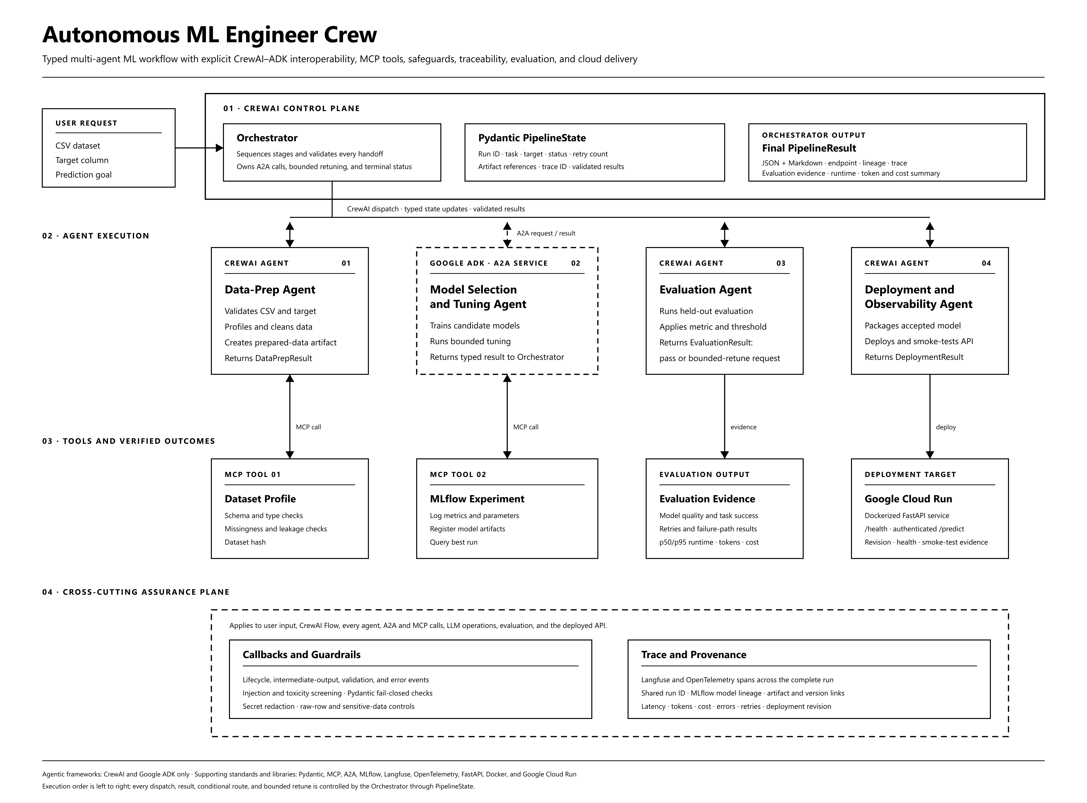
Figure 1 Final aligned implementation architecture

Implementation Contracts

Shared State
CrewAI Flow owns a Pydantic PipelineState containing the run ID, dataset and artifact references, task type, target column, current stage, retry count, model and evaluation metadata, deployment result, trace ID, and sanitized errors. Each agent reads the state it needs and writes a validated result for the next stage.

Structured Outputs
Pydantic models validate DataPrepResult, ModelSelectionResult, EvaluationResult, DeploymentResult, and the terminal PipelineResult. The final result is serialized to JSON for machines and rendered as a Markdown model report card for people. Invalid fields stop the workflow and create an audit event.

MCP Tools
MCP is a required integration rather than an optional extension. The Dataset Profile tool performs schema, missingness, target, leakage, and dataset-hash checks. The MLflow Experiment tool creates and queries runs, metrics, parameters, and artifacts. Both tools publish schemas, return Pydantic-validated data, and have success and failure tests.

A2A Interoperability
The ADK Model-Selection and Tuning Agent runs as an A2A service with an Agent Card. The CrewAI Orchestrator invokes it through an A2A client. Requests and results carry the run ID and artifact references so the same trace and provenance chain survives the framework boundary.

Agentic Patterns
The design uses a sequential workflow for the normal path, tool use for dataset and experiment operations, conditional routing at the evaluation gate, and an evaluator-optimizer loop for retuning. A configured retry budget prevents an endless loop and routes exhausted attempts to a clear terminal failure.

Monitoring Security and Traceability

Callbacks and Logging
The orchestrator wraps every stage with start, complete, validation-failure, retry, and error callbacks. The ADK agent registers before-agent, after-agent, before-tool, and after-tool callbacks. Each event includes the run ID, stage, agent, state transition, duration, result type, retry count, and sanitized error. These events support debugging without logging raw dataset rows.

Guardrails
• Validate file type, size, target column, task type, path, schema, and leakage indicators before agent execution.
• Treat the prediction goal and dataset text as untrusted input; detect prompt injection and abusive or toxic language.
• Validate A2A messages, MCP responses, handoffs, and final output with Pydantic and fail closed on invalid data.
• Restrict tools and service accounts to the permissions they need; keep secrets in Secret Manager and redact them from traces.
• Keep raw rows in deterministic Python tools and send only summaries, metrics, and artifact references to the LLM.

Observability and Provenance
Langfuse receives OpenTelemetry spans from CrewAI, ADK, A2A, MCP, LLM, evaluation, and deployment operations. MLflow records model parameters, metrics, and artifacts. One run ID links the dataset hash, preprocessing artifact, model run, evaluation decision, image digest, Cloud Run revision, and final response. This supplies an auditable path from input to deployment.

Evaluation and Cost Evidence
The final evaluation uses a public regression dataset and a public classification dataset. Repeated end-to-end runs measure model quality, pipeline success, schema-valid handoffs, retries, failures, per-stage duration, p50 and p95 runtime, LLM token use, and cloud compute time. The cost report multiplies measured usage by documented provider and Cloud Run unit prices and includes a per-run estimate plus a small monthly usage scenario.

Cloud Deployment
Docker packages the accepted model with a FastAPI service. Google Cloud Run hosts /health and authenticated /predict endpoints using a least-privilege service account and Secret Manager. Completion evidence includes the image digest, deployed revision, endpoint, health check, prediction smoke test, rollback command, sanitized logs, and a linked Langfuse trace.

End to End Workflow
- Validate the uploaded CSV, target column, and prediction goal, then initialize typed PipelineState.
- Run the Data-Prep Agent and the Dataset Profile MCP tool. Store the cleaned-data artifact and DataPrepResult.
- Call the ADK Model-Selection Agent over A2A. Train candidates and record runs through the MLflow MCP tool.
- Run the Evaluation Agent. If the model fails, return typed feedback for another bounded tuning attempt.
- When the model passes, run the Deployment and Observability Agent to build and deploy the service on Cloud Run.
- Run health and prediction smoke tests, finalize the trace and provenance manifest, and return PipelineResult as JSON and Markdown.

Definition of Done
Requirement | The project is complete when
State | A trace and integration test show each agent consuming the previous agent's typed output.
MCP | Two MCP tools run successfully in the workflow and their failure paths are tested.
Structured output | Pydantic validates every handoff and the final JSON and Markdown result.
Patterns | Pass, retry, and exhausted-retry executions follow the designed routing.
Callbacks | Intermediate output, lifecycle, validation, retry, and error events are recorded.
A2A | A CrewAI participant and the ADK model-selection service exchange real A2A messages.
Frameworks | Pinned dependencies and runtime evidence show CrewAI and ADK, with no third agentic framework.
Security | Injection, abusive input, malformed tool data, unauthorized action, and secret-leak tests pass.
Observability | A trace connects agents, A2A, MCP, model lineage, and the deployed revision.
Evaluation | The benchmark report includes model quality, reliability, runtime, tokens, and cost.
Cloud | Cloud Run serves the model and the health and prediction smoke tests pass.

Scope Boundaries
Boundary
Supported tasks: supervised classification and regression on structured CSV datasets only.
Resource limits: cap dataset size, candidate models, hyperparameter trials, retries, and cloud resources.
Fixed architecture: keep the five established agents and their original responsibilities.
Framework limit: use no additional agentic framework; supporting libraries and protocols remain infrastructure.
Evidence rule: do not claim completion until the required tests, traces, reports, and deployment evidence exist.

